Beautiful Collision

Tori Alvarez

Copyright
Copyright © 2021 by Tori Alvarez.
All rights reserved.
No part of this book may be reproduced in any form or by any electronic or mechanical means, including information storage and retrieval systems, without written permission from the author, except for the use of brief quotations in a book review.

This book is a work of fiction. Names, characters, businesses, places, events, locales, and incidents are either the products of the author’s imagination or used in a fictitious manner. Any resemblance to an actual person living or dead is entirely coincidental.

Editor:
Formatter: Tori Alvarez, Eternal Daydreamer Publishing
Cover Design:

Visit my website at
https://www.torialvarez.com/

TOC
Can leave blank.
Vellum loads this information.

Also by Tori Alvarez
The Graffiti Hearts Series

Beautiful Collision
Tragically Beautiful
Stand Alone Novel
Naïve in Love

Dedication

STORY

Chapters - Use Heading 1

Formatting paragraphs – I’m not sure if we all use a different indention space if it will look different when uploaded into Vellum.
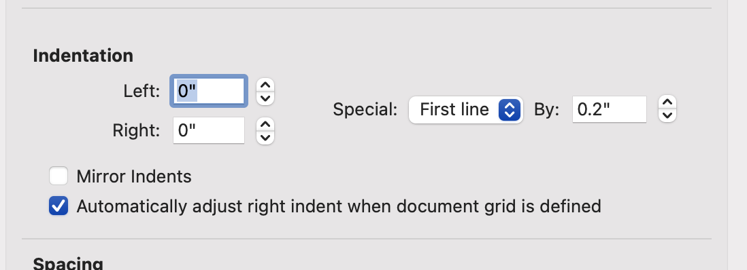

About the Author

Tori Alvarez
Tori Alvarez is an educator by day and author by night. She spent many days and nights daydreaming different stories and scenes, so she finally took the plunge and began putting them down on paper.
Tori writes real, honest romance with a hint of steam. She is a sucker for happily ever afters, so you will always find them in her books. She has three published books; Naive in Love, Beautiful Collision & Tragically Beautiful.
Tori is a Texas girl, born and raised. She lives in South Central Texas with her husband, teen daughter, dog & cat.

You can follow her at:
Website & Newsletter Sign up:
http://www.torialvarez.com

Amazon:
**NOTE: If you do not have a shortened Amazon link it will need to be a separate line like website and not below with icons. With the new Amazon Author Central it no longer allows you to create a shortened link. If you have one it can be with all the links below.
https://www.amazon.com/Tori-Alvarez/e/B079HDK15T

Please add all social links you would like me to include. All links have to be the SHORTENED URL (for print edition). Vellum will not accept the URL link to add it to symbol if it is not shortened. Of course you don’t need all these. I just added everything Vellum will upload if you want.
Facebook
Twitter
BookBub
GoodReads
Instagram
Pinterest
LinkedIn
Youtube

Acknowledgements
Blah, blah, blah….I haven’t done this yet.
.

